1st exercise

NXSOL-OJT-2024

Exported on 2024-01-23 16:37:16

Table of Contents

1 1: Create and execute the image of Arm64 Weston/wayland 3

1.1 What is Weston/wayland? 3

1.2 Environment setup 3

1.3 Source download 3

1.4 Modify 4

1.5 How to build 4

1.6 How to run 4

1.7 Results 4

1.8 Trouble shoot 5

2 2: 6

2.1 source 와 ./ 의 차이는? 6

2.2 Embedded Linux GUI 의 종류와 각각의 설명 (요약) 6

2.2.1 1. Qt for Embedded Linux 6

2.2.2 2. GTK+ (GIMP Toolkit) 6

2.2.3 3. X Window System (X11) 6

2.2.4 4. Wayland 6

2.2.5 5. FLTK (Fast Light Toolkit) 6

2.2.6 6. Embedded Wizard 6

# 1: Create and execute the image of Arm64 Weston/wayland

## What is Weston/wayland?

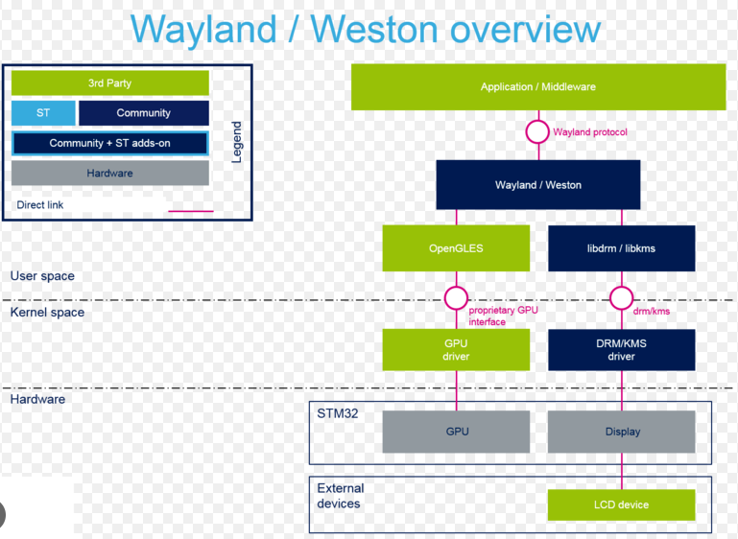

* Wayland is a **protocol** that defines the communication between a display server (compositor) and its clients (applications). It's the modern replacement for the older X11 protocol used by the X Window System.
* Weston is the reference **implementation** of a Wayland compositor. In the Wayland architecture, the compositor is a key component that manages the display, controls window positioning, and handles input events, among other tasks.

## Environment setup

Install dependencies using apt-get install

|  |
| --- |
| sudo apt-get update  sudo apt-get install gawk wget git-core diffstat unzip texinfo gcc-multilib build-essential chrpath socat cpio python3 python3-pip python3-pexpect xz-utils debianutils iputils-ping python3-git python3-jinja2 libegl1-mesa libsdl1.2-dev xterm python3-subunit  mesa-common-dev lz4 |

## Source download

Download poky (kirkstone) because dunfell results in some issues

|  |
| --- |
| git clone -b kirkstone git://git.yoctoproject.org/poky.git |

## Modify

Modify this line in mybuild/conf/local.conf  so that ARM64 is used

|  |
| --- |
| MACHINE ?= "qemuarm64" |

Optional (It works well without these line because of the default setting)

|  |
| --- |
| ISTRO_FEATURES:append = " wayland"  CORE_IMAGE_EXTRA_INSTALL += "wayland weston" |

## How to build

Build using Poky and Bitbake

|  |
| --- |
| source poky/oe-init-build-env mybuild  cd mybuild  bitbake -k core-image-weston |

## How to run

Run the built image using QEMU

|  |
| --- |
| runqemu qemuarm64 |

QEMU is a free and open-source emulator. It emulates a computer's processor through dynamic binary translation and provides a set of different hardware

## Results

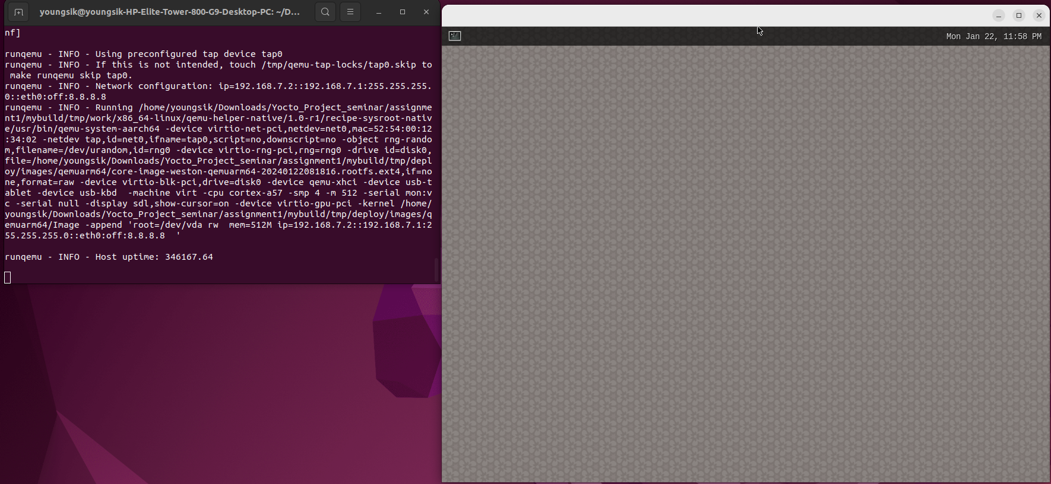

## Trouble shoot

* Got an error saying it cannot continue the build without lz4, and solved it by installing lz4
* Got an error because of using DISTRO_FEATURES as described the official document of Dunfell and solved it by using **DISTRO_FEATURES:append = " wayland"** from the kirkstone document

# 2:

## source 와 ./ 의 차이는?

* Source  is used to execute the environment setup script (e.g. source oe-init-build-env)
* Using ./ does not achieve this

## Embedded Linux GUI 의 종류와 각각의 설명 (요약)

### 1. Qt for Embedded Linux

* **Description**: Qt for Embedded Linux is a popular framework that offers a comprehensive set of tools and libraries for developing GUIs. It's known for its rich set of features and cross-platform support.

### 2. GTK+ (GIMP Toolkit)

* **Description**: GTK+ is a free and open-source cross-platform widget toolkit for creating graphical user interfaces. It’s part of the GNU Project and originally developed for the GIMP image editor.

### 3. X Window System (X11)

* **Description**: X11 is a windowing system for bitmap displays. It is the standard window system for UNIX and UNIX-like operating systems, including Linux.

### 4. Wayland

* **Description**: Wayland is a modern protocol for a display server, intended as a simpler replacement for X11. It’s gaining popularity in the Linux world for its efficiency.

### 5. FLTK (Fast Light Toolkit)

* **Description**: FLTK is a lightweight, cross-platform GUI toolkit. It’s known for its small size and speed, making it suitable for embedded systems with limited resources.

### 6. Embedded Wizard

* **Description**: Embedded Wizard is a tool for developing high-performance GUIs specifically for embedded systems.